**Processing Document**

1. Copy Paste all columns from Libraries.xlsx into a new excel file and save the file as workbook1.xlsl
2. Copy the FID Column from Presubmission Community Meeting.xlsx into the workbook1.xlsl under the FID column.
3. Copy the three columns with titles: Meeting_Location_Address, Meeting_Location_City and Meeting_Location_Zip from Presubmission Community Meeting.xlsx and paste into the workbook1.xlsl under the columns with titles: Address, City and Zip Code respectively by aligning the rows with the respective FIDs.
4. Copy the column Meeting_Location_Place from Presubmission Community Meeting.xlsx into the workbook1.xlsl under the column Place by aligning the rows with the FID.
5. Copy the column geom from Presubmission Community Meeting.xlsx into the workbook1.xlsl under the column geom by aligning the rows with the FID.
6. Copy all the remaining columns from the Presubmission Community Meeting.xlsx and paste into workbook1.xlsl with the titles. Align the titles in the 1st row and the remaining rows according to the FID.
7. Sort all the Data with focus on the column City sorted in an alphabetic manner from A to Z.
8. Sort all the Data at a second level with focus on the column Name sorted in an alphabetic manner from A to Z.

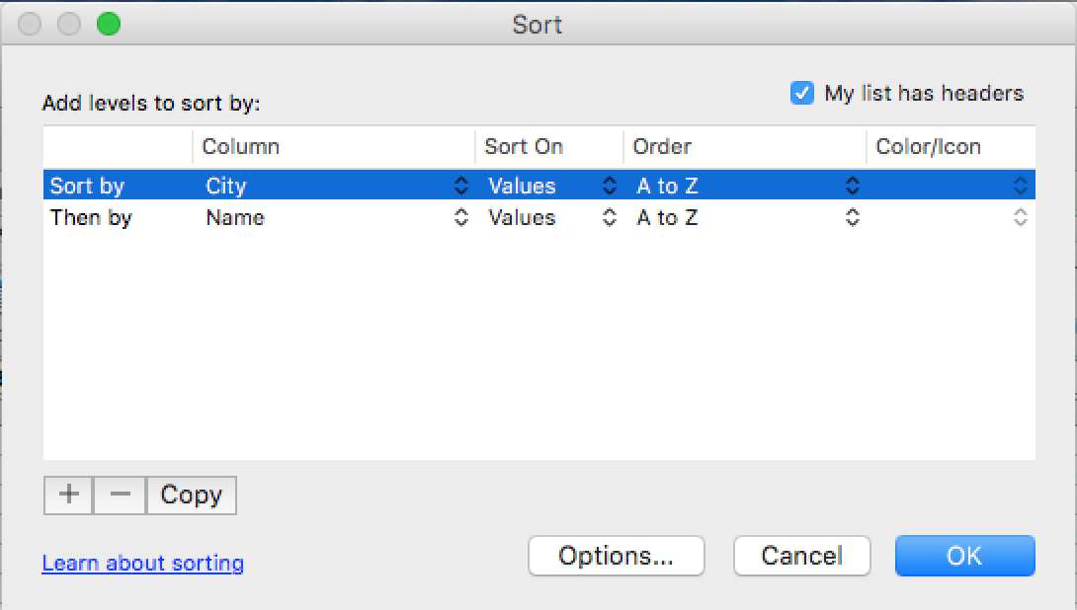

1. Save the workbook as Libraries & Presubmission Community Meeting.xlsx